**Name of the programme**: Seminar on GST and employment opportunities through CAT

**Date of the programme**: 9.2.2018

**Organized by**: Career Counselling Cell in association with CAT Directorate, Institute of Chartered Accountants of India (ICAI), Delhi.

**Name and details of the resource persons:** Expert from the CAT Directorate, Institute of Chartered Accountants of India (ICAI), Delhi.

**Objective of the programme**: The objective of the seminar is to create awareness and understanding among participants about the Goods and Services Tax (GST) and the employment opportunities through the Common Admission Test (CAT).

**Outcomes**: The outcomes of the programme includes

1. The significance of GST as a major tax reform and its impact on various sectors of the economy.
2. Comprehensive overview of the diverse job opportunities that arise due to the implementation of GST, especially in the field of management after qualifying the CAT exam.
3. Identification and evaluation of potential career paths in the areas of finance, taxation, consulting, and entrepreneurship.

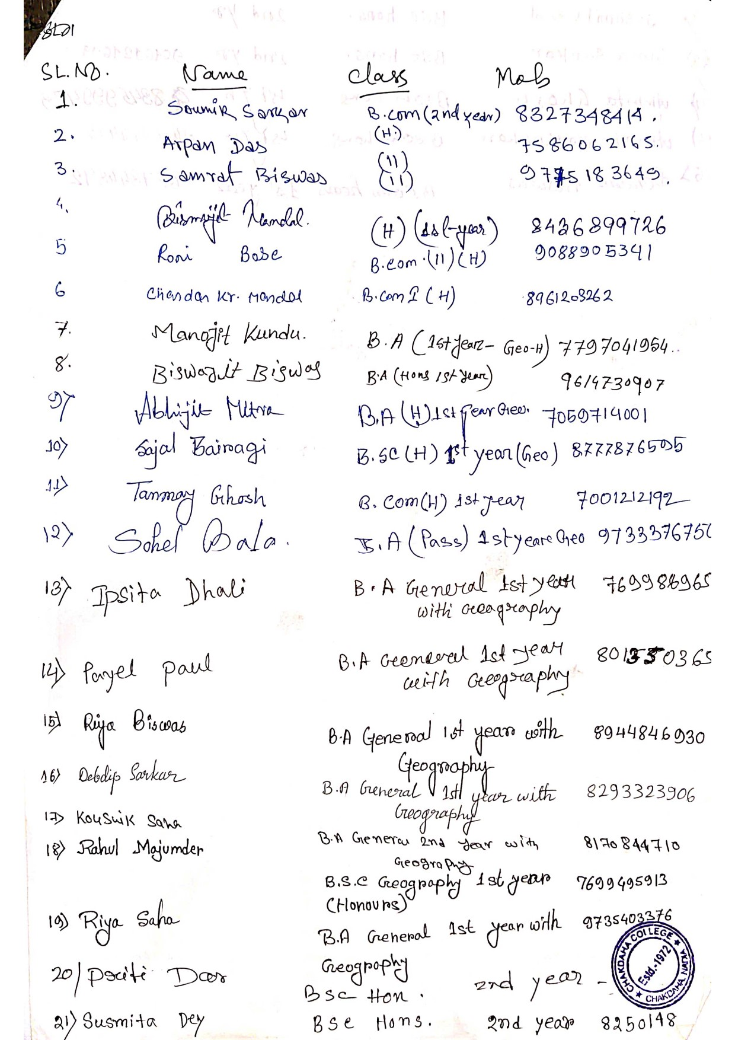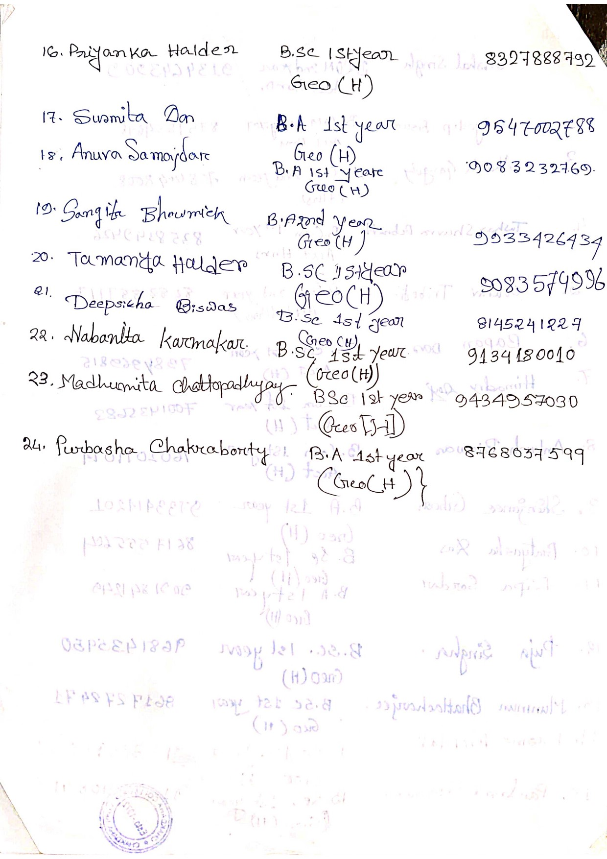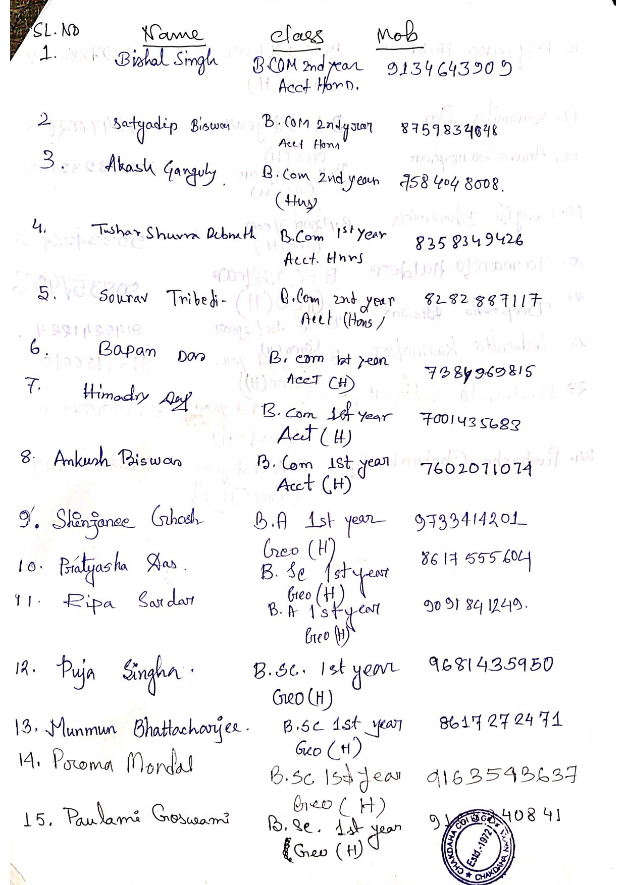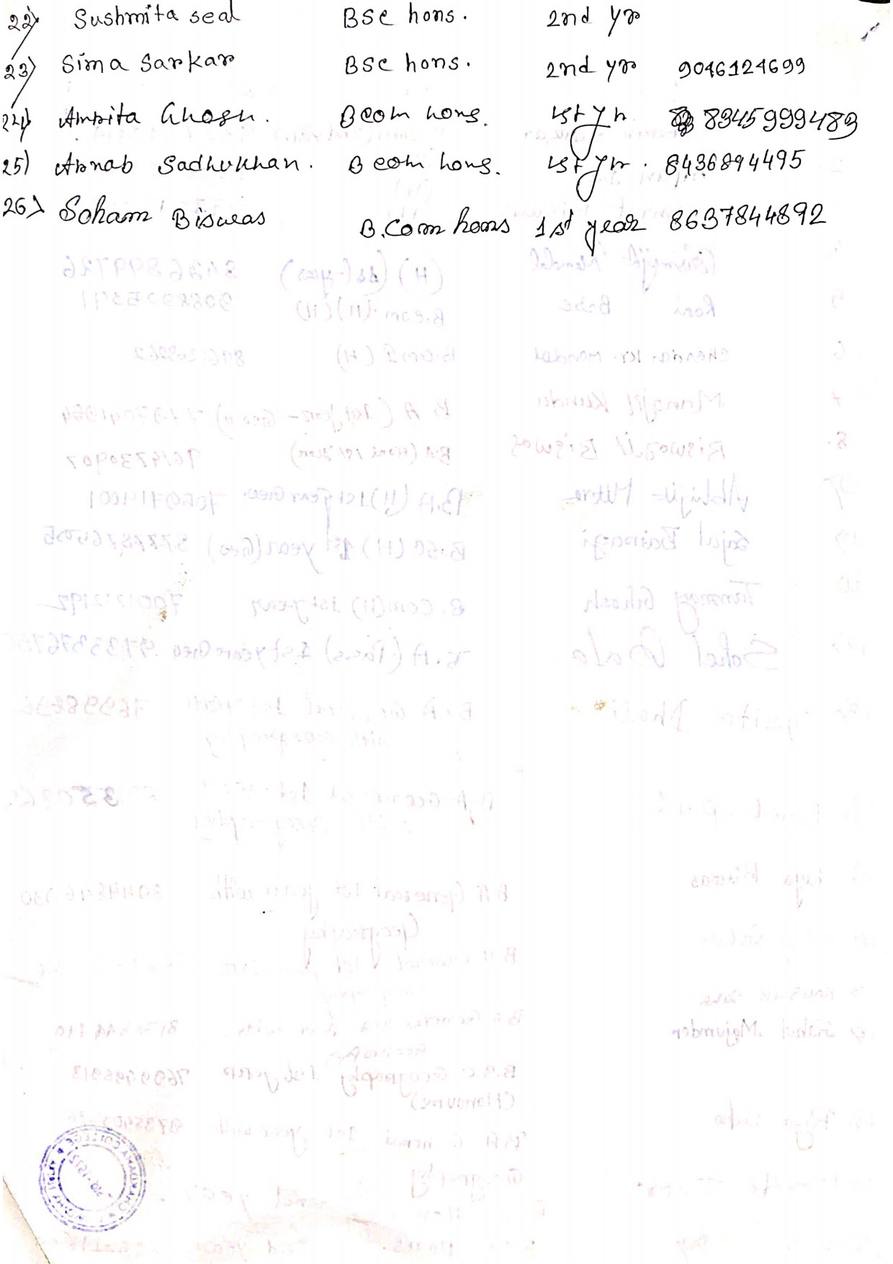

List of Students Participated